Join us for
A Prayer & Reflection Vigil:
STANDING WITH THE KURDS IN CRISIS
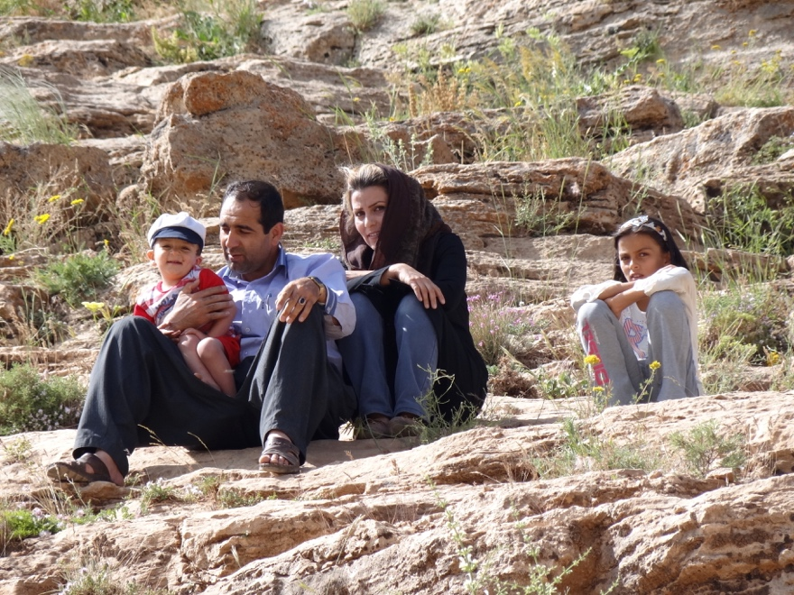
https://en.wikipedia.org/wiki/Creative_Commons https://www.flickr.com/people/41000732@N04

We stand in solidarity with the Kurdish people as they have
become victims of an attempted genocide.
We call upon our government to honor its alliance with the Kurds, defend them in the time of need and demonstrate the humanitarian values which are the hallmarks of America!

WHEN: Sunday, November 3, at 3:00 pm
WHERE: St. Peter’s Episcopal Church
2400 Middle Road, Bettendorf, Iowa (map)

SPONSORING ORGANIZATIONS
Diocese of Davenport QCAIR One Human Family QCA
Progressive Action for the Common Good Quad Cities Interfaith

