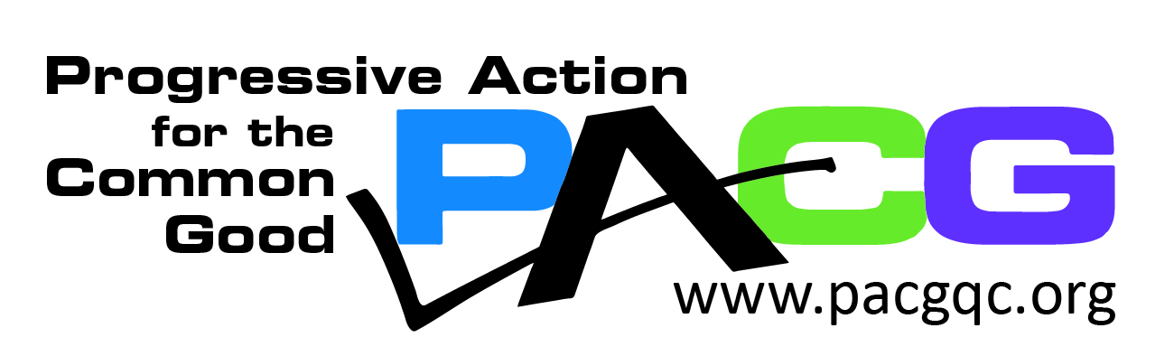

FOR IMMEDIATE RELEASE
Date: Monday, February 13, 2023

Contact: Allison Ambrose, PACG Vice President
Phone: 563-508-6011 or 563-676-7580
Email: qcprogressiveaction@gmail.com
www.pacgqc.org

Navigating Complex Policies Within a Broken System - an Immigration and Refugee Summit

(Davenport, IA) - Progressive Action for the Common Good (PACG) presents the Immigration and Refugee Summit, “Navigating Complex Policies Within a Broken System,” on Saturday, February 25th from 10:00 am to noon at Eastern Iowa Community College in Davenport, IA. One Human Family-QCA and Quad Cities Interfaith are co-sponsors of this event.

This summit will help educate participants about the various laws and regulations that affect immigrants and refugees, including visa processing, granting asylum, entrance quotas, available resources, and protections. Panelists will provide updates on current laws and will also discuss the challenges of implementing this legislation.

“We are really excited to bring together this group of panelists who have diverse experiences with immigrant and refugee populations to educate the public on the various obstacles and challenges faced by these populations. Our hope is that with a better understanding of what these populations face, we can work to make a difference,” says Allison Ambrose, Vice President of PACG.

The panelists work with immigrants and refugees in our community and will discuss obstacles faced while navigating our current immigration system. They will also offer suggestions to fix what is not working.

Panelists include:
Summer Allchin, a solo practitioner with Allchin Law Office, PLLC, in Muscatine, Iowa who practices exclusively in immigration law. She focuses primarily on family-based immigration, consular processing, waivers, citizenship applications, and domestic abuse cases.

Karina Garnica and Gricelda Garnica are Immigration Counselors at the Catholic Diocese of Davenport. They have more than 20 years of experience in legal family reunification and also help DACA (Deferred Action for Childhood Arrivals) recipients.

Mayra Hernandez, a DACA recipient, will talk about her personal experiences and how current policies affect DACA.

Ratko Rastovic, Program Director at World Relief Quad Cities, arrived in the US in 1999 as a refugee from the former Yugoslavia. He will discuss the Afghan Adjustment Act and other issues that impact refugees.

Fred Tsao, the Senior Policy Counsel at the Illinois Coalition for Immigrant and Refugee Rights (ICIRR), will review current issues that affect immigrant and refugee rights.

Spanish translation will be provided.

As progressives, PACG empowers people to take action for positive change and social justice by coordinating a network of community forums and events aimed at educating and engaging citizens to work for the common good of all. Our core values are Social Justice, Empowerment, Diversity, Sustainability and Community.

For more information about this event, please visit the Progressive Action for the Common Good website at http://www.pacgqc.org or contact Allison Ambrose at qcprogressiveaction@gmail.com.

