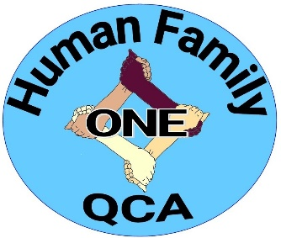
News Release:
From: One Human Family of the Quad-Cities Area
Event: Spreading the good of the stimulus dollars
Contact: Connie Lannan, 309-945-5152
Rabbi Henry Karp, 563-505-8823
Organizations join forces to help stimulus dollars go even further through the ‘Spread the Relief’ campaign
On March 11, President Biden signed into law the American Rescue Plan, which is offering $1.9 trillion in coronavirus (COVID-19) relief funding, including direct payments of up to $1,400 to individuals who make up to $75,000 annually. One Human Family of the QCA, the Immigration Office of the Diocese of Davenport, Metrocom NAACP, Progressive Action for the Common Good and Quad Cities Interfaith would like to make those stimulus dollars benefit those most in need with their “Spread the Relief” campaign.
“The goal of the campaign is to call upon our neighbors in the greater Quad-City area whose income and financial security have not been negatively impacted, but who will be receiving stimulus checks from the federal government, to consider donating all or part of their stimulus funds to programs and agencies that are providing assistance to those most seriously affected by the pandemic,” says Rabbi Henry Karp, co-founder of One Human Family.
This team effort is aimed at shining a light on and providing funds to area agencies and programs that have been offering the following types of help:
- Food assistance
- Housing assistance
- Health care
“Food, shelter and health care are fundamental to the well-being of every individual. The pandemic has devastated all three of these areas. So many in our region have suffered job loss, food insecurity and the loss of their health insurance. By teaming with agencies that provide these types of assistance, we hope those who have been spared these hardships will be able to pay it forward and help those who have been so severely impacted during this time,” says Allison Ambrose, Ph.D., president of Progressive Action for the Common Good.
“We have done our best to organize a list of some of the more well-known agencies and programs that are assisting people in the greater Quad-City area in these three areas of concern,” Rabbi Karp says. “We have included contact information for the agencies we have listed. We may have missed some organizations, but this is a starting point. Our goal is to help those in the most need.”
Find the list of programs and agencies to which stimulus dollars can be donated on these websites:
- One Human Family of the QCA (www.onehumanfamilyqca.org)
- Immigration Office of the Diocese of Davenport (www.davenportdiocese.org)
- Metrocom NAACP of Davenport (www.davenportnaacp.org)
- Progressive Action for the Common Good (www.pacgqc.org)
- Quad Cities Interfaith (www.qcinterfaith.org)
Please, do not send your donation checks to the sponsoring organizations listed above. Send them directly to the programs of your choice listed on the above-mentioned websites. Put “COVID Relief” in the memo line of your check.

###

